

Use Case: Heatmap – DAD-2402

ID: | https://onetakeda.atlassian.net/browse/BICN-77604 - Create Configuration Screen
Title: | Heat Map Visualization
Objective: | To deliver a configurable an interactive Heatmap component that enables high-level visualization of key metrics across domains such as:  · Data Quality (DQH): Source system data health  · Enterprise Risk (ERM): Site-level risk exposure  · Process Capability (GPCM): Predicted failure rates across products
Primary Actor: | Takeda End Users
Preconditions: | The user must be able to access the Dashboard.  The user must be able to add tiles and select the bundle.
Postconditions: | User successfully generates a Heatmap Visualization
Main  Success Scenario: | Section 1: Add Tile – Basic Selections – X and Y Axis are mandatory selections.  .  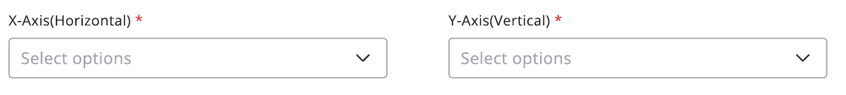  Section 2: Secondary Selections – optional  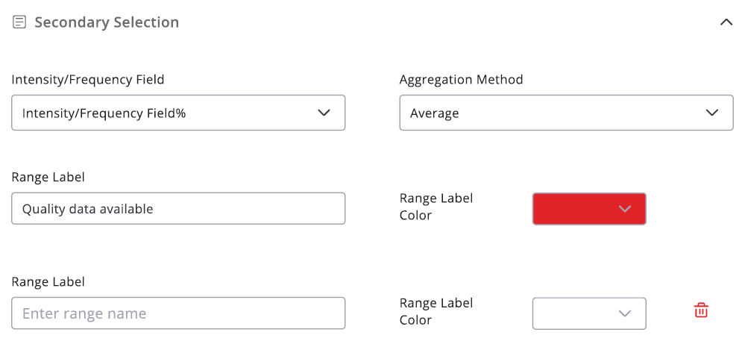  Section 3: Advanced Selections – Enablement & Advance Settings - optional  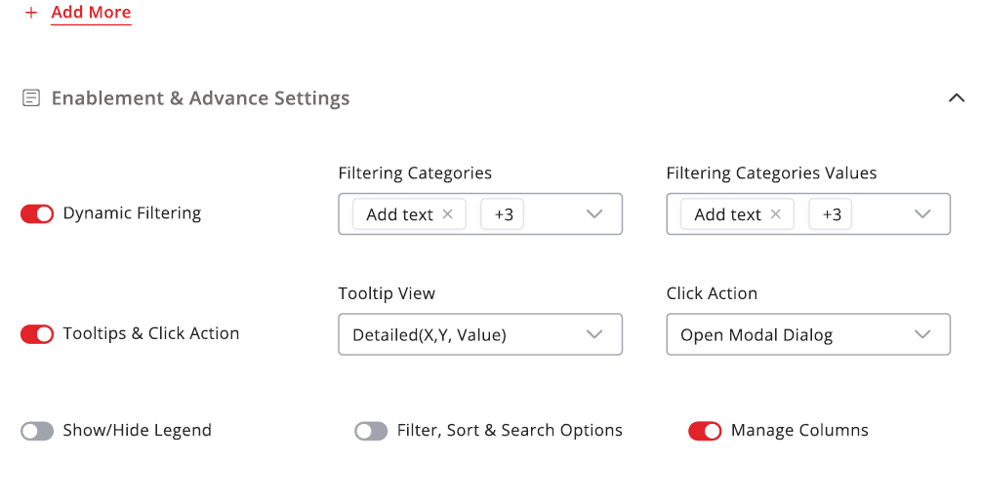  Section 4: Visible & Ordered Columns - Optional  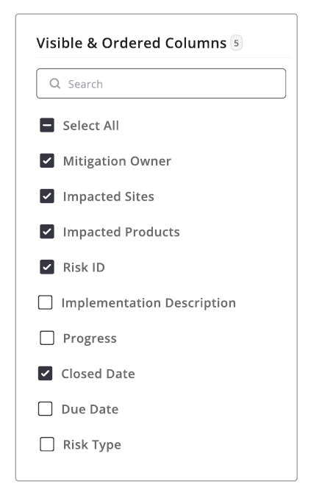  Section 5: Continue Navigating Back/ Cancel / Create Tile
Stakeholders: | - Product Owners: DQH, ERM, GPCM  - Designers: Figma-based UI/UX contributors  - Developers: Frontend and backend teams (Team Wanda)  - QA/Testers: QTest contributors  - Delivery Leads: @Praveen Viswanath, @Ashok Swaminathan
Benefits: | - Unified visualisation across domains  - Configurable and scalable component  - Enhanced decision-making through intuitive UI  - Reusable framework for future Heatmap applications
Status: | Blocked - require data set
Owner: | Victor Bianchi
Priority: | 1

